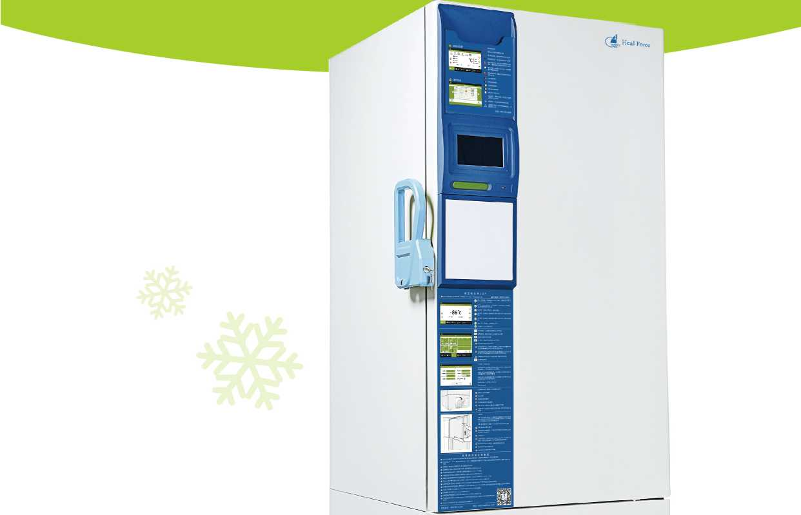
Heal Force
Low temperature cold chain Products
Heal Force Life Science Instrument Series
Healthcare Equipment
Medical Equipment
Electrosurgical Generator
Medical Ceiling Pedant
Surgical Light
Surgical Table
Anesthesia Machine
Patient Monitor
Infant Incubator Series
Infant Radiant Warmer Series
Infant Bilirubin Phototherapy Series
Neonatal Monitor
Low Temperature Plasma Sterilizer
Optical Navigation system for Neurosurgery iForce Digital OR Integration
Life Science Laboratory Equipment
Biosafety Cabinet
Clean Bench
Cytotoxic Cabinet
Tri-gas/CO2 Incubator Laboratory Centrifuge
Water Purification System PCR Thermal Cycler Laminar flow clean bench Freezers and Refrigerators
www.healforce.com
Pulse Oximeter
Easy ECG Monitor
Spot-check Monitor
Healthcare Internet of Things Tele-medicine
Heal Force International Trading (shanghai) Co., Ltd.
6788 Songze Road, Qingpu District, Shanghai 201706, P.R. China
Tel: +86 21 62728646, Email: export@healforce.com, Fax: +86 21 62710529
Information is subject to change without prior notice.
© 2020 Heal Force.

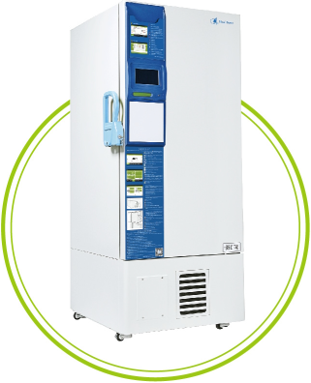
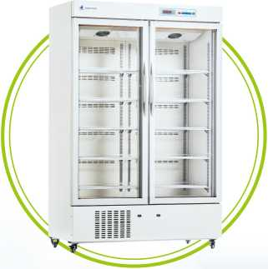
• Various volume specifications
• Touch screen operation
- Low noise technology
- Dual independent system
temperature freezer
Economic Type: 2-8 C refrigerator
Reliable control system • Forced-air cooling system •
Service-free drainage system • Wide voltage range 187V-242V available •

WHOWEARE

Renowned provider for medical and laboratory equipment.
Heal Force are dedicated to leading a healthier life by deliverying professional solutions on medical treatment, life science research and personal healthcare. We specialises in designing, manufacturing of medical and laboratory refrigerators and freezers, including ultra low temperature freezers, deep freezers, pharmacy refrigerators, etc.
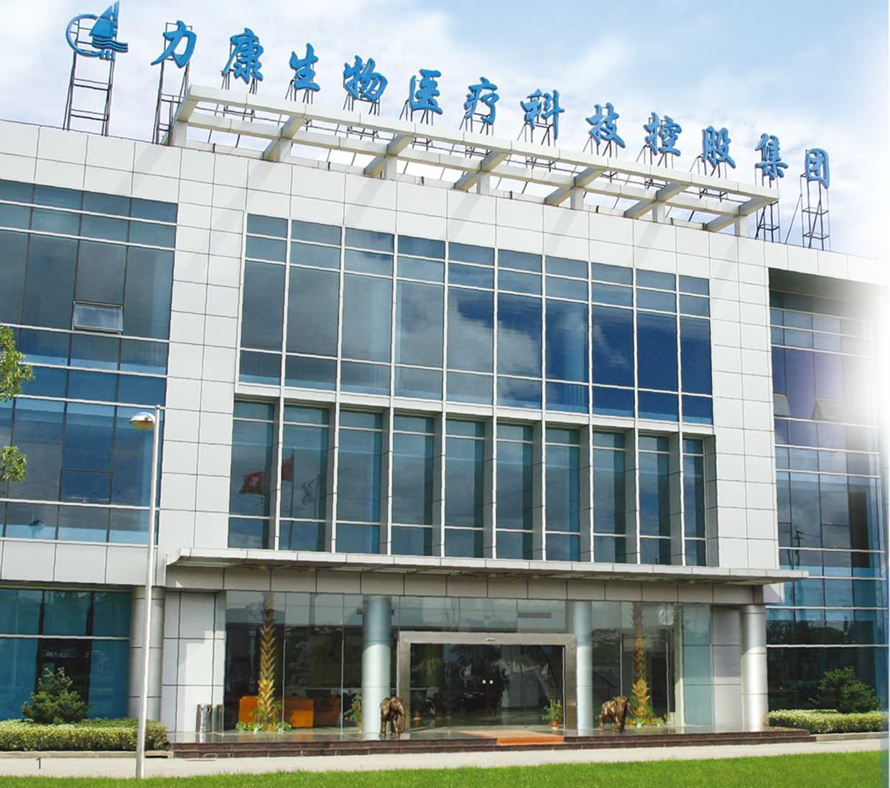
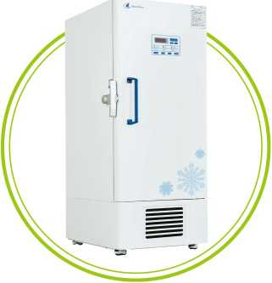
Headquartered in Hong Kong and over 30 years experience in medical and life science field, we have grown steadily with over 1000 employees, and our products are exported to many countries and regions.

"Low temperature cold chain product series
Heal Force 's low temperature products include:2-8 C pharmacy refrigerator、-25C/-40 C deep freezer> -86 C ultra low
High-end Type: -86 C ultra low temperature freezer
• Two-compressor cascade refrigeration system
• VIPII technology
• Multiple alarm systems
Economic Type: -86C/-40C/-25C low temperature freezer
- Well-known brand compressor
- Visual and audible alarm system
- Low noise design
- Independent research and development of mixed refrigerant
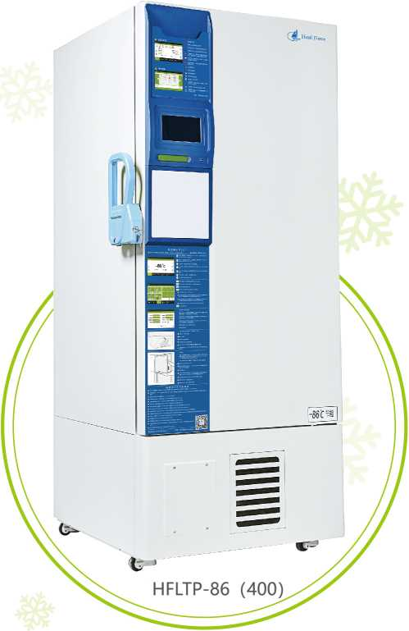
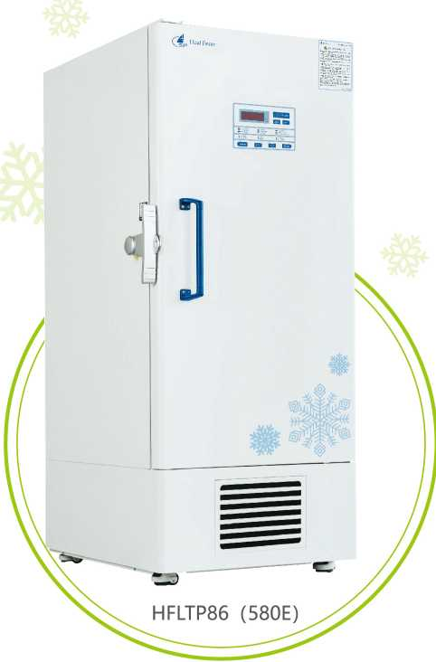

-86°C Ultra low temperature freezer
Applications: preservation of viruses, bacteria, vaccines, biological tissues, drugs, special materials, etc.
Used in the fields of biomedicine, scientific research, electronics, chemical industry and so on
- Two-compressor cascade refrigeration system specially designed for cryogenic applications
- Wide available voltage range: 198V~242V
- Accurate temperature control system with ±0.1 °C accuracy
- Visual and audible alarm system: High/low temperature,power failure, abnormal voltage, sensor error, filter screen check, condenser clean, high ambient temperature and door ajar alarm
- Build-in back-up battery to display temperature and to operate audible and visual alarm system for up to 72 hours without AC power
- Realize historical temperature curve query and download, standard USB port, easy to download data
- HC refrigeration system can save energy by 50%
- Low noise design

-86 C Ultra low temperature freezer
Applications: preservation of viruses, bacteria, vaccines, biological tissues, drugs, special materials, etc.
Used in the fields of biomedicine, scientific research, electronics, chemical industry and so on
- Independent research and development of mixed refrigerant can save energy by 50%
- Accurate temperature control system with ±0.1 °C accuracy
- VIPIIPLUS technology, special compact design for entering elevators
- Visual and audible alarm system: High/low temperature, power failure, abnormal voltage, sensor error, filter screen check, low battery, condenser clean, high ambient temperature and door ajar alarm
- 304 stainless steel inner chamber
- Keyboard lock, password protection to avoid change parameter accidently
- Low noise design

Product model | HFLTP 86 (400) | HFLTP 86 (580) | HFLTP 86 (830) | HFLTP 86 (580D)
External dimension(mm) | 891*992*1945 | 891*1155*1994 | 1179*1135*1994 | 891*1155*1994
Internal dimension(mm) | 606*575*1180 | 606*738*1310 | 894*718*1310 | 606*738*1310
Rated power(w) | 845 | 815 | 890 | 800
Weight (kg) | 215 | 249 | 275 | 249
Temperature(°C) | -40~-86 | -40~-86 | -40~86 | 40~-86
Volume(L) | 408 | 588 | 838 | 588
Sample quantity(2ml frozen storage tubes) 28800 |  | 40000 | 60000 | 40000
Interior material |  | 304 stainless steel
Compressor/Brand |  | 2/SECOI | P
Cooling Type |  | Direct cooling
Power Supply(V/Hz) |  | 220/50
High/low temperature, sensor error, power failure, door ajar, high ambient temp, condenser clean, low battery, filter screen check, abnormal voltage

Product model | HFLTP 86 (340) | HFLTP 86 (680) HFLTP 86 (580E) | HFLTP 86 (830E)
External dimension(mm) | 854*1072*1907 | 1354*1072*1907 872*1192*1994 | 1160*1172*1994
Internal dimension(mm) | 488*607*1140 | 990*607*1140 606*738*1310 | 894*718*1310
Rated power(w) | 870 | 808 800 | 840
Weight (kg) | 190 | 260 249 | 275
Temperature(°C) | -40~-86 | -40~-86 -40~-86 | 40~-86
Volume(L) | 340 | 688 588 | 838
Sample quantity(2ml frozen storage tubes) 19200 |  | 38400 40000 | 60000
Interior material |  | 304 stainless steel
Compressor/Brand |  | 2/SECOP
Cooling Type |  | Direct cooling
Power Supply(V/Hz) |  | 220/50
Alarm | High/low temperature, sensor error, power failure, door ajar, high ambient temp, condenser clean, low battery, filter screen check, abnormal voltage

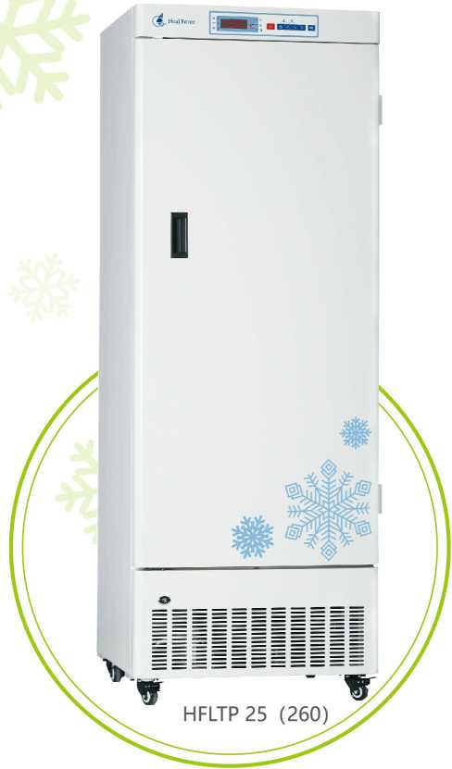
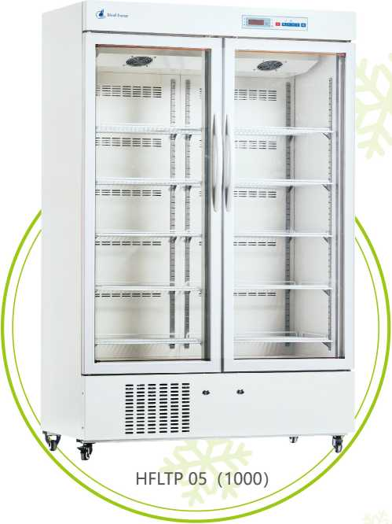

-25 C/-40 °C Deep Freezer
-40°C low temperature freezer： Used in the fields of seed preservation, cryopreservation material experiment, biological product preservation, plasma preservation, etc.
-25C low temperature freezer： Used in the fields of plasma preservation, reagent preservation, vaccine preservation, biomaterial preservation, etc.
- Accurate microprocessor controller to ensure consistent cabinet temperature
- Chemically stable, CFC-free, commercially available and environmentally safe refrigerant
- Embedded handle, easy for one-man operation
- Visual and audible alarm system: High/low temperature, power failure, sensor error, door ajar, thermostat failure
- Controller error protection: the cooling system will remember the normal working cycle and keep working depending on this memory when controller or sensor failed
- Optional test hole, convenient for temperature monitoring

2-8 C Pharmacy Refrigerator
Used in the fields of preservation of biological products, reagents, vaccines, etc.
- Reliable temperature control system with ±0.1 °C accuracy
- Forced-air cooling system ensure frost-free cabinet and good temperature uniformity
- Color spray steel plate inner chamber for friendly using and easy cleaning
- Service-free drainage system ensure no water in the cabinet
- Controller error protection: the cooling system will remember the normal working cycle and keep working depending on this memory when controller or sensor failed
- Wide voltage range 187V-242V available

Product model | HFLTP 25 (320) | HFLTP 40 (320) HFLTP 25 (260) | HFLTP 40 (260) | Product model | HFLTP 05 (1000) | HFLTP 05 (310)
External dimension(mm) | 673*676*1886 | 673*676*1886 673*676*1630 | 673*676*1630 | External dimension(mm) | 1220*872*1885 | 640*582*1880
Internal dimension(mm) | 508*455*1393 | 508*455*1393 508*455*1137 | 508*455*1137 | Internal dimension(mm) | 1100*684*1325 | 540*425*1380
Rated power(w) | 280 | 300 280 | 300 | Rated power(w) | 310 | 215
Weight (kg) | 113 | 113 98.5 | 98.5 | Weight (kg) | 207 | 92.5
Temperature(°C) | -10—25 | -30~-40 -10~-25 | -30~-40 | Temperature(°C) | 2〜8 | 2~8
Volume(L) | 328 | 328 268 | 268 | Volume(L) | 1006 | 316
Interior material | Steel plate with surface-spraying treatment |  |  | Interior material | Steel plate with surface-spraying treatment
Compressor/Brand |  | 1/Imported |  | Compressor/Brand | 1/Imported
Cooling Type |  | Direct cooling |  | Cooling Type | Forced air cooling
Power Supply(V/Hz) |  | 220V/50 |  | Power Supply(V/Hz) | 220V/50
Alarm | High/low temperature, sensor error, power failure, door ajar, high ambient |  |  | Alarm | High/ low temperature, sensor error, | power failure, door ajar
 | temp, condenser clean, low battery, filter screen check, abnormal voltage

